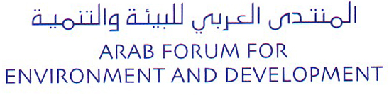
Tel: +961 1 321800, Fax: +961 1 321900
info@afedonline.orgwww.afedonline.org

MEMBERSHIP APPLICATION FORM
Please fill in the form below
MEMBERSHIP APPLICATION FORM
Membership Category | Corporate | NGO |  | Academic | Media |  | Observer |  | Professional Services
Name of Institution
CEO / President
(specify exact title)
Type of operation
Country
P.O. Box
Mailing Address | Building |  | Street |  |  | City |  | Zip/Postal Code
Telephone
Fax
E-mail
Type of membership | Local / National  Regional/ Multinational
Number of Employees
Annual turnover
Contact person | Name:
 | Title:
 | Telephone:
 | Fax:
 | E-mail:
Environmental policy:
Describe briefly the environmental policy of the institution. Attach annual report or any relevant literature.

Our institution is committed to the protection of the environment and the principles of sustainable development. It thus subscribes to the goals of AFED and supports its mission.
I Accept

Please send the completed form by post or fax, with the original signature, and include supporting material if applicable, to the address of AFED secretariat: Arab Forum for Environment & Development,
Eshmoun Building, Rue Damas, Downtown Beirut, P.O.Box 113-5474, Beirut Lebanon
Tel: +961 1 321800, Fax: +961 1 321900.
You may also send a scanned copy of the filled application form to the following email: info@afedonline.org
You can download the application from AFED’s website: www.afedonline.org and send online
Date: ______________________
Signature: __________________

